**Practical 8**

|  |  |  |  |
| --- | --- | --- | --- |
| |  |  |  | | --- | --- | --- | | |  |  | | --- | --- | | |  | | --- | | **Aim:** Write a VHDL Code to implement 8 bit up down counter using behavioral modeling | | | |

|  |  |  |
| --- | --- | --- |
| |  |  | | --- | --- | | |  | | --- | |  | |   **Code:**  library IEEE;  use IEEE.STD_LOGIC_1164.ALL;  use IEEE.std_logic_arith.all;  entity U_D_bh_8B is  Port ( clk : in STD_LOGIC;  rst : in STD_LOGIC;  M : in STD_LOGIC;  q : out STD_LOGIC_VECTOR (7 downto 0));  end U_D_bh_8B;  architecture Behavioral of U_D_bh_8B is  begin  process(clk,rst,M)  variable t:integer:=0;  variable t1:STD_LOGIC_VECTOR(7 downto 0);  begin  if(rising_edge(clk)) then    if(M='1') then  t:=t + 1;  elsif(m='0') then  t:=t - 1;  end if;    end if;    t1:= conv_std_logic_vector(t, 8);    q<=t1;  end process;  end Behavioral; |

**RTL DIAGRAM:** 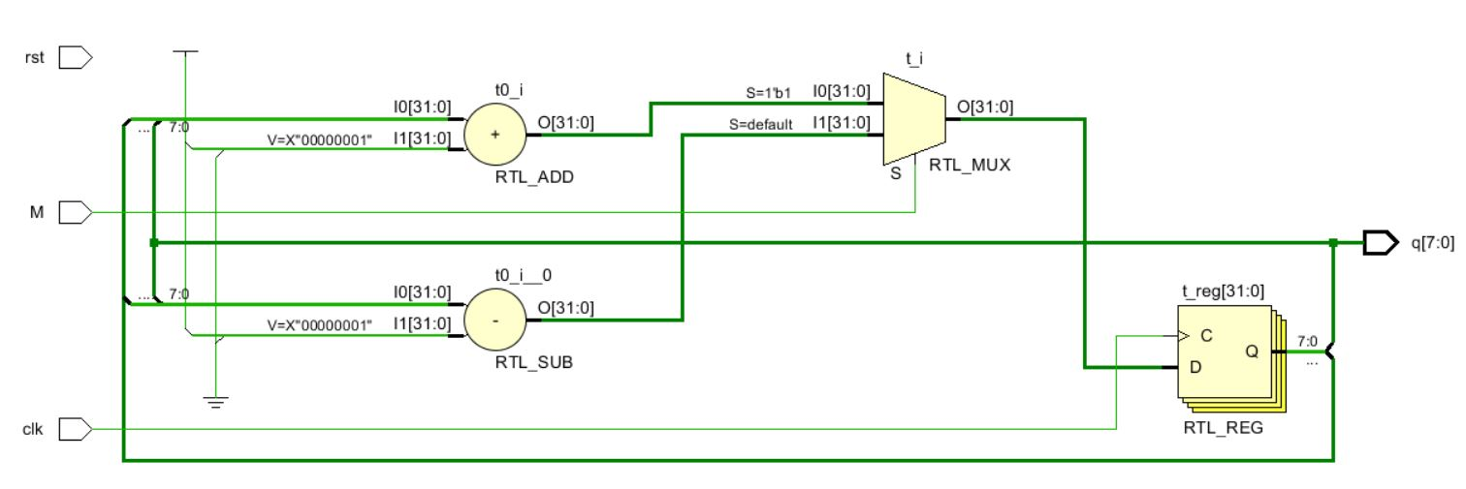

**Test bench Code :**

library IEEE;

use IEEE.STD_LOGIC_1164.ALL;

entity Tb_U_D_bh_8b is

-- Port ( );

end Tb_U_D_bh_8b;

architecture Behavioral of Tb_U_D_bh_8b is

component U_D_bh_8b is

Port ( clk : in STD_LOGIC;

rst : in STD_LOGIC;

M : in STD_LOGIC;

q : out STD_LOGIC_VECTOR (7 downto 0));

end component U_D_bh_8b;

signal m1,clk1,rst1:std_logic;

signal cout1:std_logic_vector(7 downto 0);

begin

X1:U_D_bh_8b port map(clk1,rst1,m1,cout1);

process

begin

rst1<='0';

wait for 5ns;

rst1<='1';

wait;

end process;

process

begin

clk1<='0';

wait for 5ns;

clk1<='1';

wait for 5ns;

end process;

process

begin

m1<='1';--upcount

wait for 500ns;

m1<='0';--downcount

wait;

end process;

end Behavioral;

**SIMULATION WAVEFORM :**

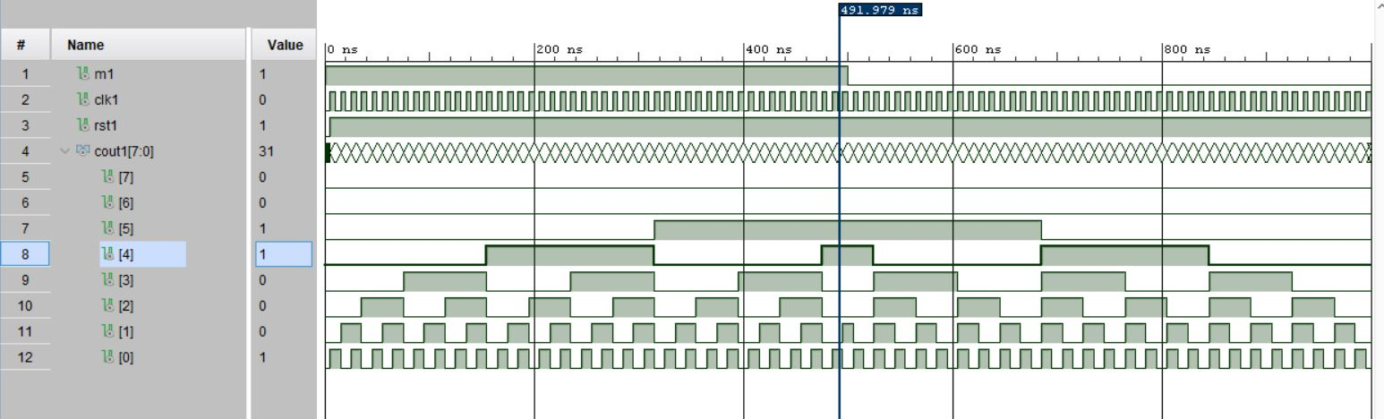

**SYNTHESIS SUMMARY:**

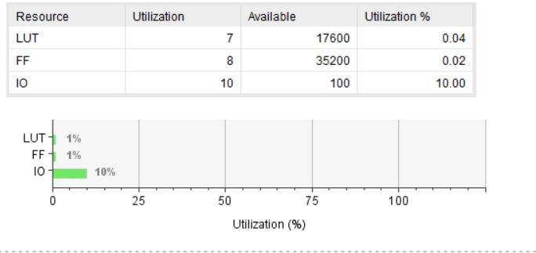

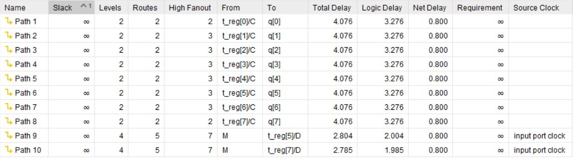

Maximum Combinational Delay: 4.076nSec